**Enroll in Duo Security MfA – Landline/non-smartphone**

**Save a copy of these instructions to your desktop to use when the VPN/Citrix disconnects.**

1. Logout out of VPN or Citrix session
2. In Chrome, go to new VPN site: <https://VPN.NGLIC.com> or new Citrix site: <https://Citrix.NGLIC.com> and login
3. Follow on-screen instructions to:
   1. Select Landline
   2. Add phone number
   3. Select Type of phone
4. On the **My Settings & Devices** box, leave the **When I log in** option to: **Automatically Call this Device**
5. On the **Choose an authentication method** box, click **Call Me**
6. When your phone rings, you can press any button to approve
7. You should now be logged into the new VPN or Citrix site
8. Each day after rebooting or logging out here are your steps:
   1. Go to <https://VPN.NGLIC.com> (NGL MfA VPN shortcut on desktop) or <https://Citrix.NGLIC.com>
   2. Login
   3. Click Call Me
   4. Press any button on your phone when you receive the call

Step 1: Logoff current VPN or Citrix session (on your computer)

Close all browser windows.

Then follow the set of instructions below based on which system you login to (VPN or Citrix).

**If you are a VPN User**: On your NGL laptop or desktop, *Right-Click* the Citrix Gateway icon in your system tray (click the up arrow next to your clock in the bottom right hand corner of your screen if you don’t see the icon) and select *Logoff.* If you don’t see the Logoff option, you are already logged off.

**

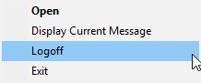

If you do not see the Citrix Gateway icon in your system tray, search for “Citrix Gateway” in your Start menu and click on it.

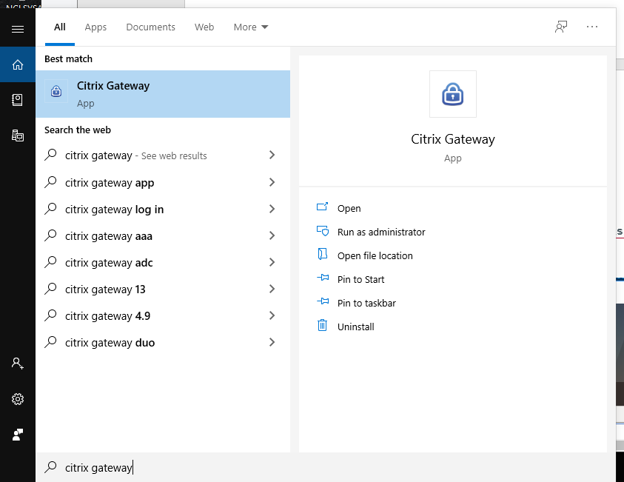

Hit the “Logoff” button, to log out of your current VPN session.

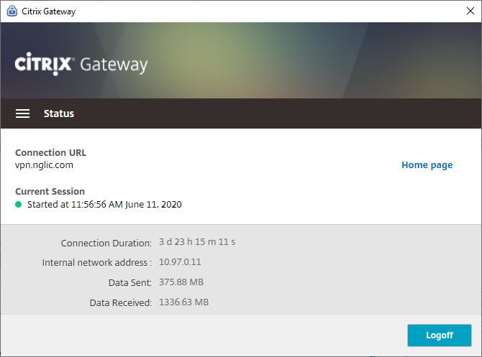

Select the first 4 checkboxes, then choose the option to Cleanup.

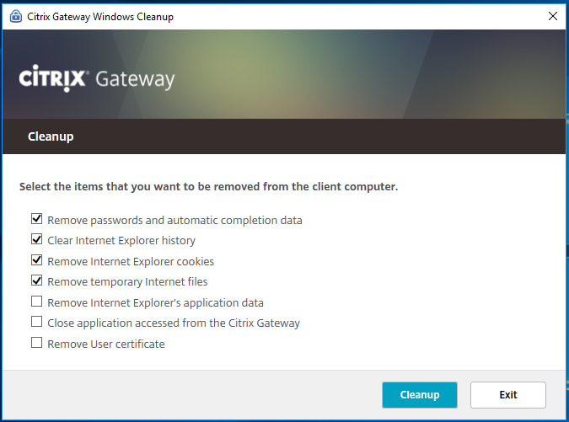

**If you are a Citrix User:** On your laptop or desktop, *Right-Click* the Citrix Workspace icon in the system tray (click the up arrow next to your clock in the bottom right hand corner of your screen if you don’t see the icon) and select *Connection Center*.



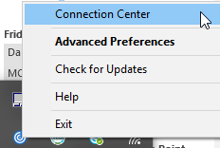

In the Connection Center highlight your connection and select *Disconnect.*

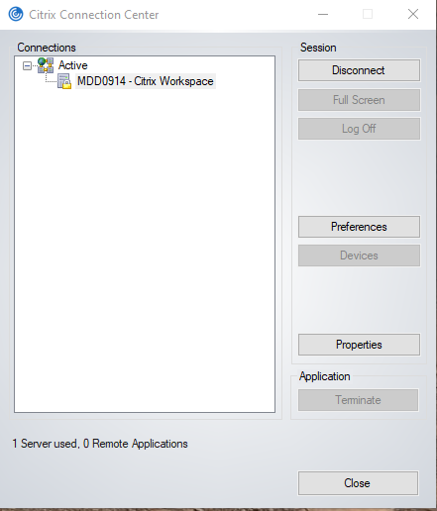

Click Yes on the screen below.

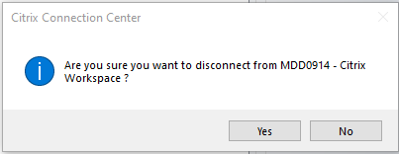Step 2: Navigate to the new VPN or new Citrix site (on your computer)

Open a Chrome web browser and type (or copy/paste) in the address bar the VPN or Citrix URL below based on which you use to connect:

**For VPN**: [**HTTPS://VPN.NGLIC.COM**](HTTPS://VPN.NGLIC.COM)

Select *Always* to not get this prompt again*.*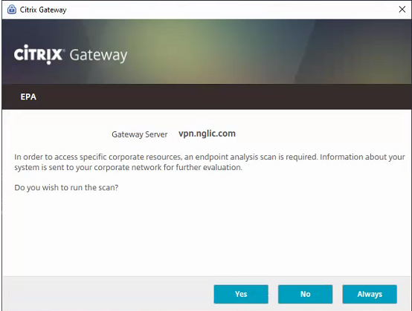

Logon with your username and password for the network.

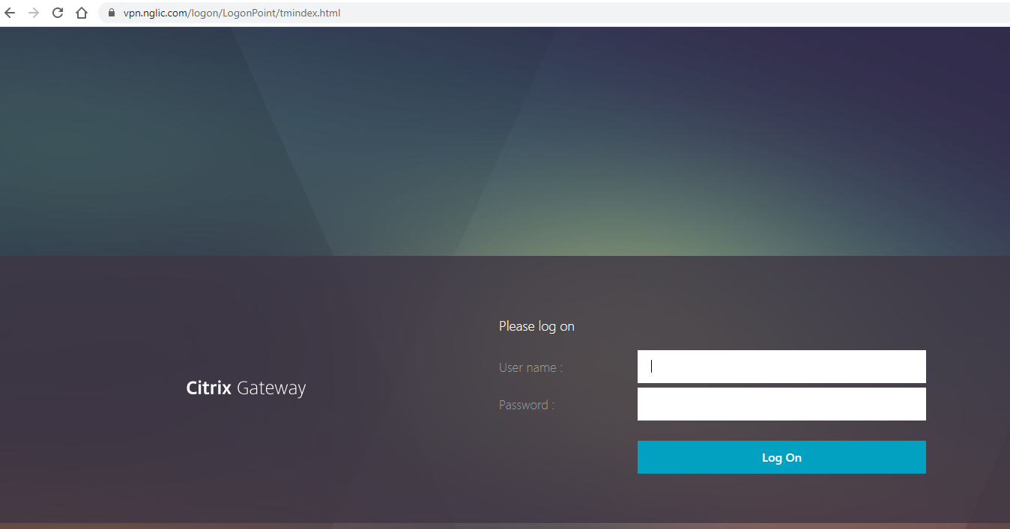

**For Citrix**: [**HTTPS://CITRIX.NGLIC.COM**](HTTPS://CITRIX.NGLIC.COM)

You may see this screen. If you do, click Open Citrix Workspace Launcher

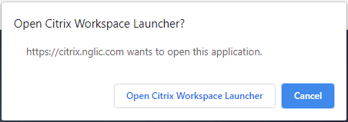

Step 3: Welcome Screen (on your computer)

Click Start setup to begin enrolling your device.

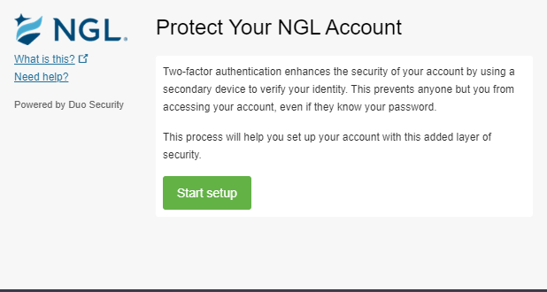

Step 4: Choose Your Authentication Device Type

Select Landline and click Continue.

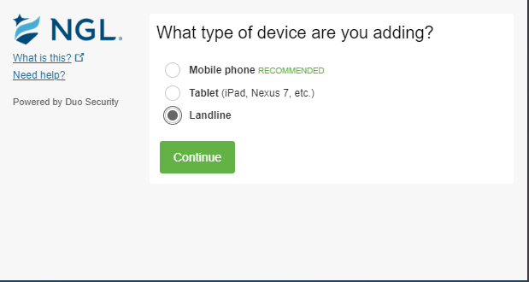

Step 5: Enter your phone number

Enter your phone number and extension (if you have one).

Please be advised that this phone number can be a desk phone, home phone or other mobile device that can accept phone calls, but it must be available to be answered any time you want to authenticate to the VPN or Citrix.

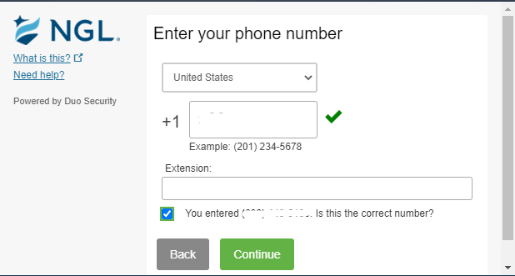

Step 6: Make this your default device

Select the option to Automatically call this device from the drop-down list. Click *Save* and then click Continue to *Login*.

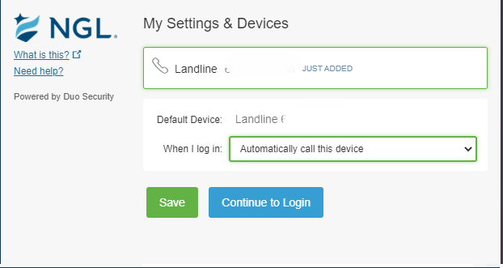

Step 7: Call Me

After successful enrollment, click the Call Me button to initiate a call to your landline.

Once you answer the call, you can push any key on your phone, and you will be authenticated.

Note: The NGL IT Customer Service Team can provide a one-time bypass code if the landline you designated can’t receive a call.

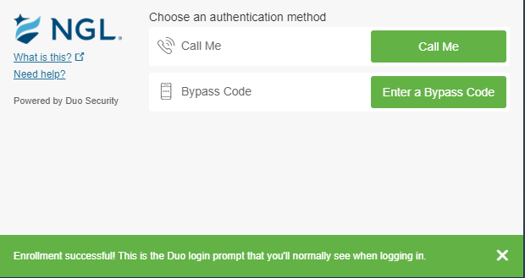

After pushing any key on your phone, this screen will appear.

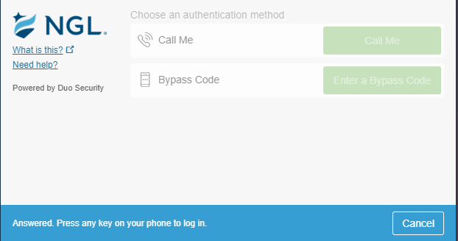

You have successfully completed enrollment!

Please continue to use the VPN or Citrix connection as you normally would to go about your business.

IT Customer Service Contact Info:

608-257-5611, ext 5555