**Enroll in Duo Security MfA – Smartphone/Mobile Phone (Android and iOS)**

**Save a copy of these instructions to your desktop to use when the VPN/Citrix disconnects.**

**Quick Steps (for more details see the following pages):**

1. Logout out of VPN or Citrix session
2. In Chrome, go to new VPN site: <https://VPN.NGLIC.com> or new Citrix site: <https://Citrix.NGLIC.com> and login
3. Follow on-screen instructions to:
   1. Select Mobile phone
   2. Add phone number
   3. Select Type of phone
4. Install DUO Mobile on your phone:
   1. Be sure to allow Camera Access to scan the QR code
   2. If you get a security check, click **Okay, Got it**.
5. Scan QR code to activate your account
6. On the **My Settings & Devices** box, leave the **When I log in** option to: **Ask me to choose an authentication method**
7. On the **Choose an authentication method** box, click **Send me a Push**
8. Find the notification on your phone and click Approve
9. You should now be logged into the new VPN or Citrix site
10. Each day after rebooting or logging out here are your steps:
    1. Go to <https://VPN.NGLIC.com> (NGL MfA VPN shortcut on desktop) or <https://Citrix.NGLIC.com>
    2. Login
    3. Click Send me a Push
    4. Click Approve on the notification on your phone

Step 1: Logoff current VPN or Citrix session (on your computer)

Close all browser windows

Then follow the set of instructions below based on which system you login to (VPN or Citrix).

**If you are a VPN User**: On your NGL laptop or desktop, *Right-Click* the Citrix Gateway icon in your system tray (click the up arrow next to your clock in the bottom right hand corner of your screen if you don’t see the icon) and select *Logoff.* If you don’t see the Logoff option, you are already logged off.

**

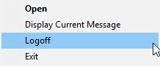

If you do not see the Citrix Gateway icon in your system tray, search for “Citrix Gateway” in your Start menu and click on it.

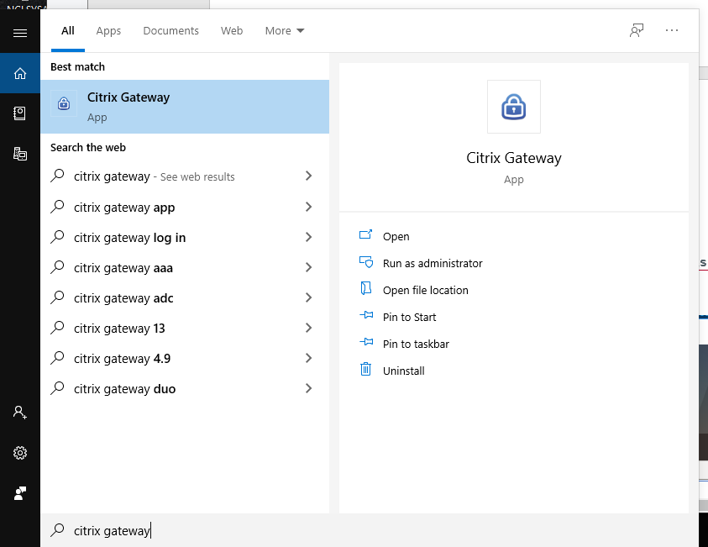

Hit the “Logoff” button, to log out of your current VPN session.

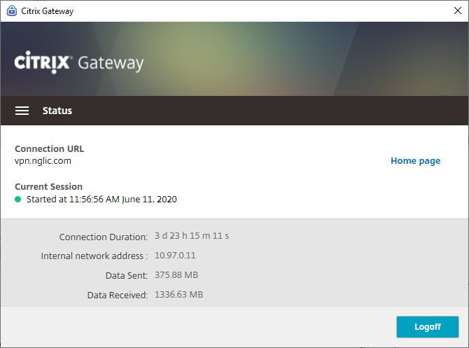

Select the first 4 checkboxes, then choose the option to Cleanup.

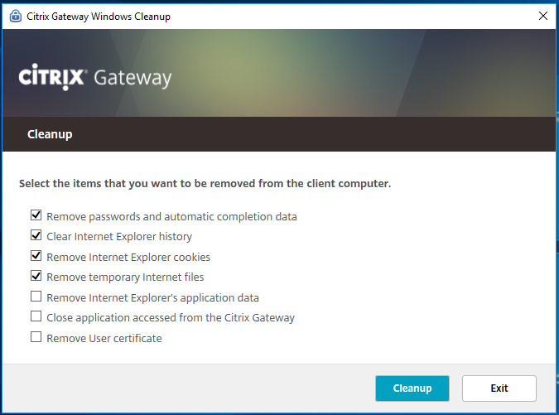

**If you are a Citrix User**: On your laptop or desktop, *Right-Click* the Citrix Workspace icon in the system tray and select *Connection Center*.



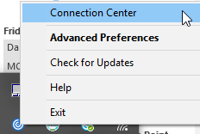

In the Connection Center highlight your connection and select *Disconnect.*

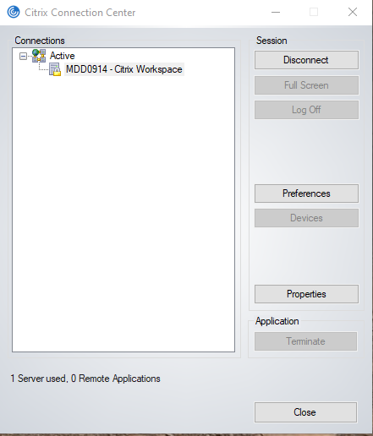

Click Yes on the screen below.

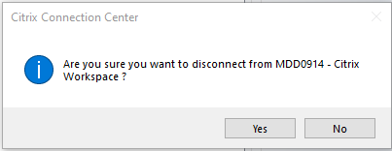Step 2: Navigate to the VPN or Citrix (on your computer)

Open a Chrome web browser and type (or copy/paste) in the address bar the VPN or Citrix URL below based on which you use to connect:

**For VPN**: [**HTTPS://VPN.NGLIC.COM**](HTTPS://VPN.NGLIC.COM)

Select *Always* to not get this prompt again*.*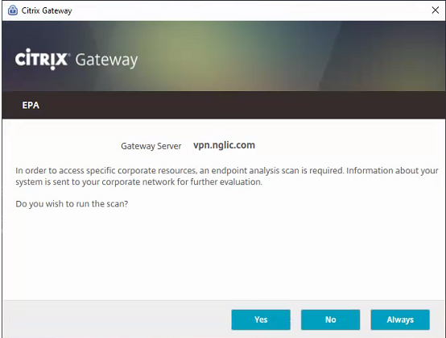

Logon with your username and password for the network.

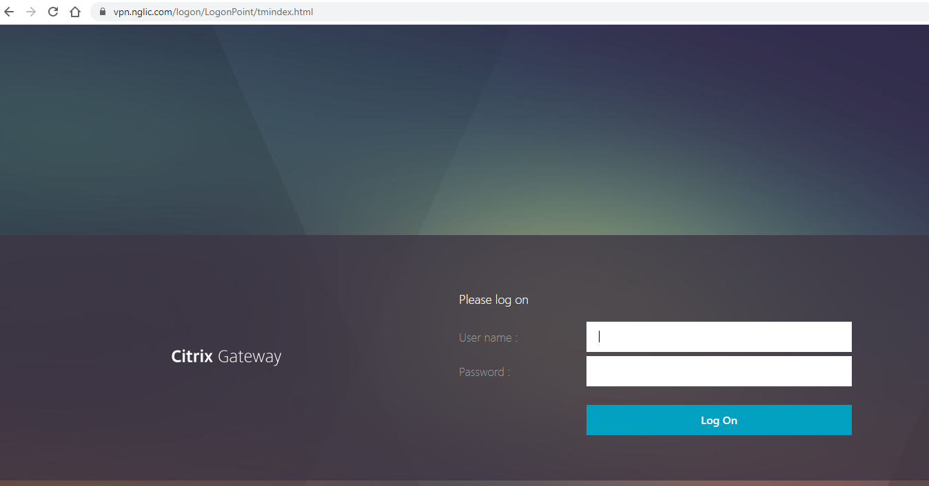

**For Citrix**: [**HTTPS://CITRIX.NGLIC.COM**](HTTPS://CITRIX.NGLIC.COM)

You may see this screen. If you do, click Open Citrix Workspace Launcher

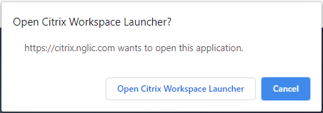

Step 3: Welcome Screen (on your computer)

Click Start setup to begin enrolling your device.

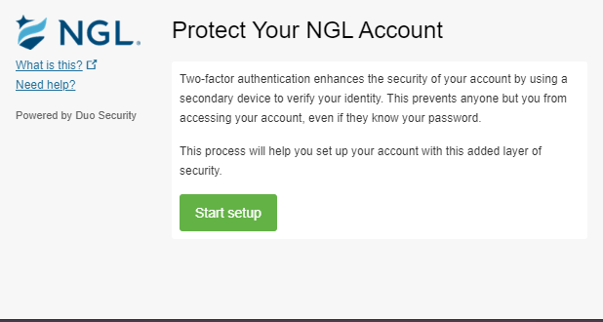

Step 4: Choose Your Authentication Device Type (on your computer)

Select Mobile phone and click *Continue*.

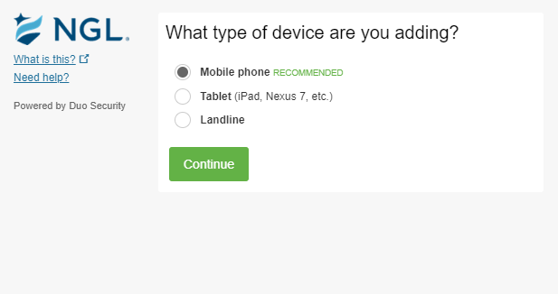

Step 5: Setting up your device (on your computer)

Enter your phone number.

Double-check that you entered it correctly, check the box, and click Continue.

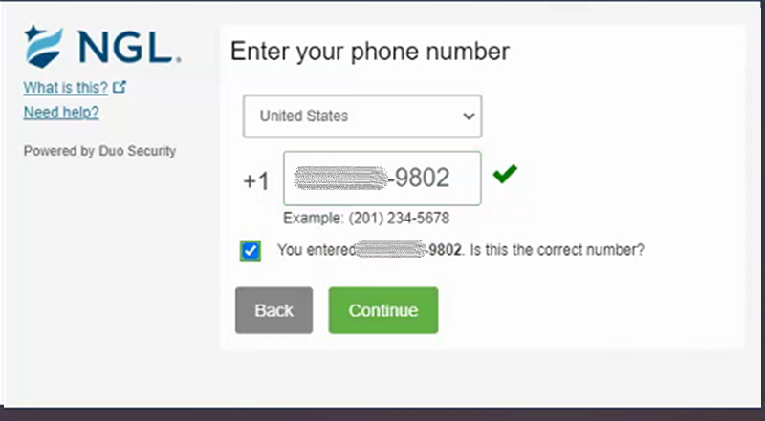

Step 6: Choose Platform (on your computer)

Choose your phone type and click Continue.

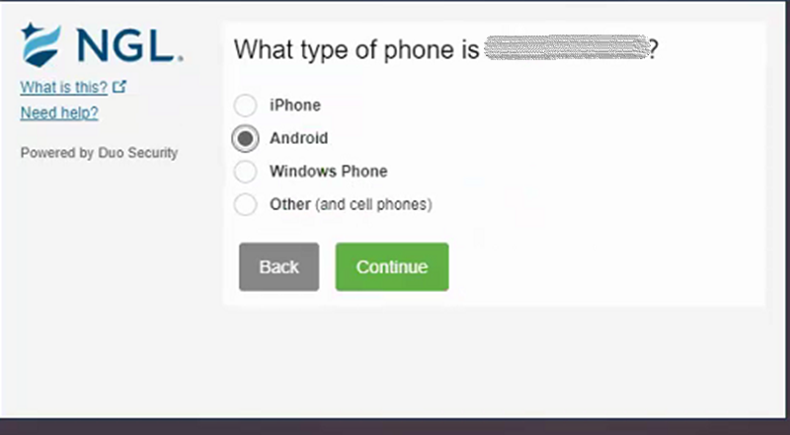

Step 7: Install Duo Mobile (on your phone)

Follow the instructions on your computer to install Duo Mobile.

After installing the Duo Mobile app on your phone, return to the enrollment window on the computer and click **I have Duo Mobile installed.**

Note: If you already installed Duo Mobile prior to this, just proceed by clicking **I have Duo Mobile installed**.

Android: 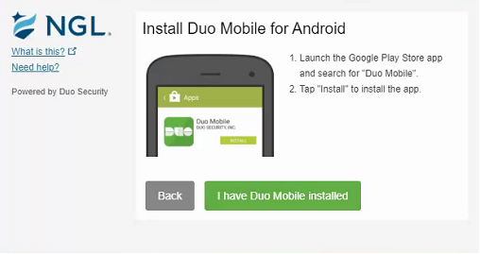

iOS: 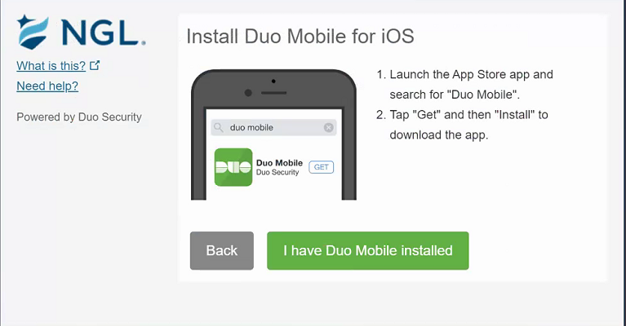

As part of the installation process, you may get prompts to allow access to your device’s camera. If so, click OK to allow.  
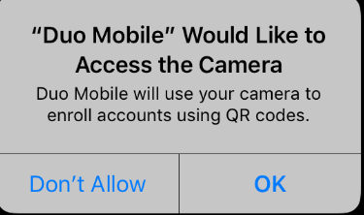  
  
You may also get a popup that indicates that your device needs a security health checkup. If so, click *Okay, got it* to allow this process.

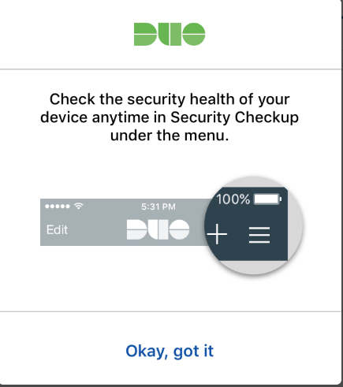

Once the app is installed and working successfully, you’ll see this:

Step 8: Activate Duo Mobile (on your computer)

Follow the instructions on your computer to link the app to your NGL account.

The Continue button is clickable after you scan the barcode successfully. Click Continue.

Android: 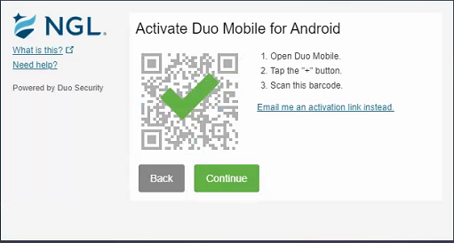

iOS: 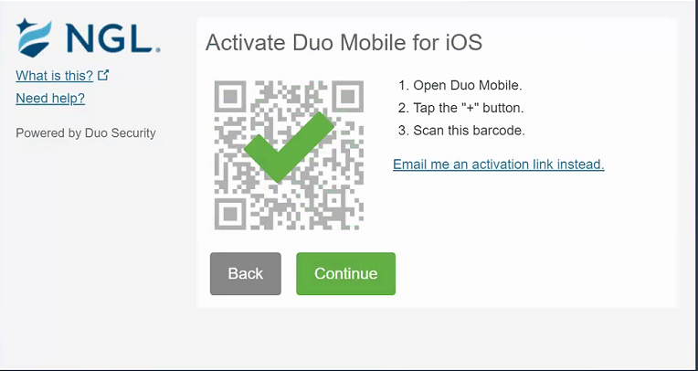

Can't scan the barcode? Click Email me an activation link instead. and follow the instructions.

Step 9: Configure Device Options (on your computer)

Choose the option to “***Ask me to choose authentication method***” in the **When I log in** field and click **Save**.

Click **Continue** to login to proceed to the Duo Prompt.

Android: 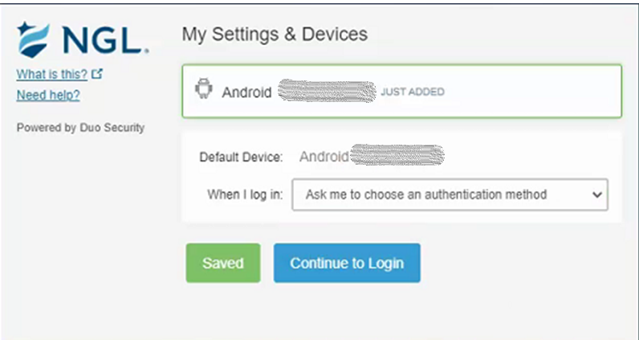

iOS: 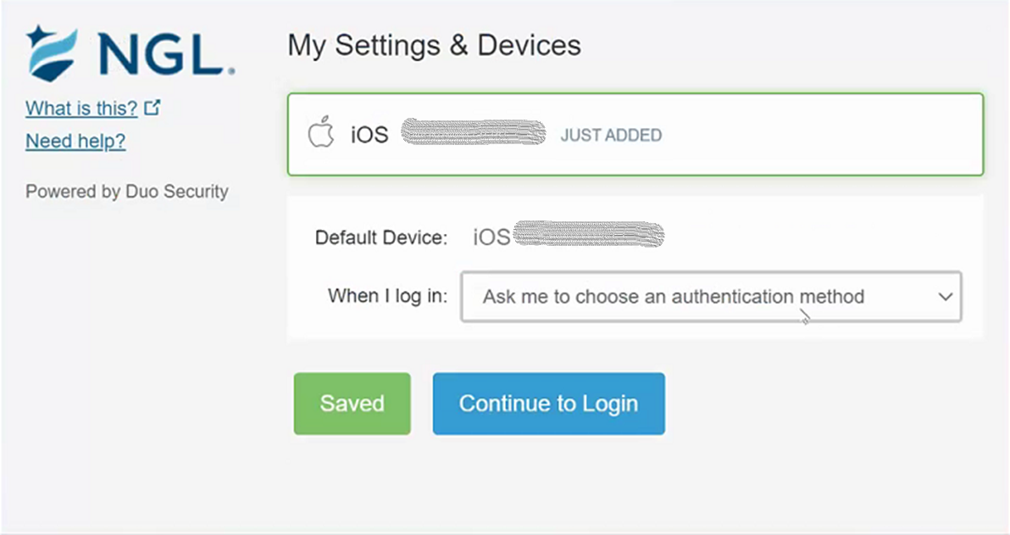

Congratulations!

Your device is ready to approve Duo MfA authentication requests.

Click **Send me a Push** to login.

Tap **Approve** on the Duo login request received on your phone.

Then proceed to work as normal.

