Updating Citrix Gateway Plugin from version 12 to version 13

- Save anything you need and close all open applications and reboot your machine.
- Click the Start/Windows button:

- Start typing Software Center and click on the Software Center App circled below.
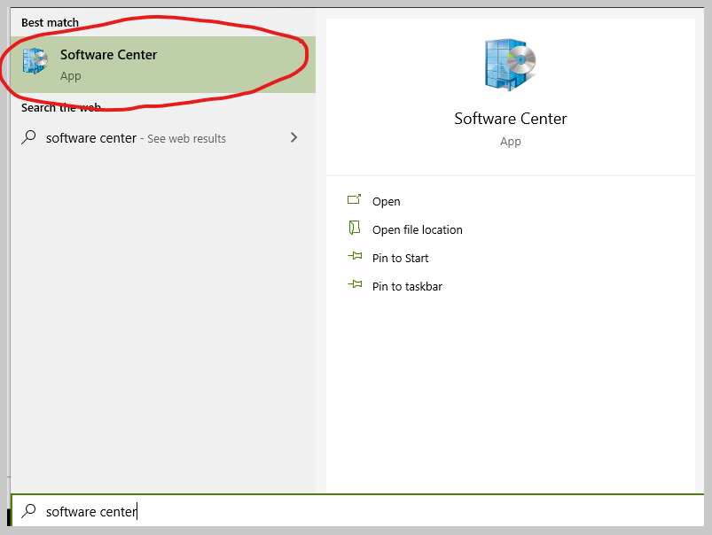

- This will open the Applications tab in Software Center and you should see this:
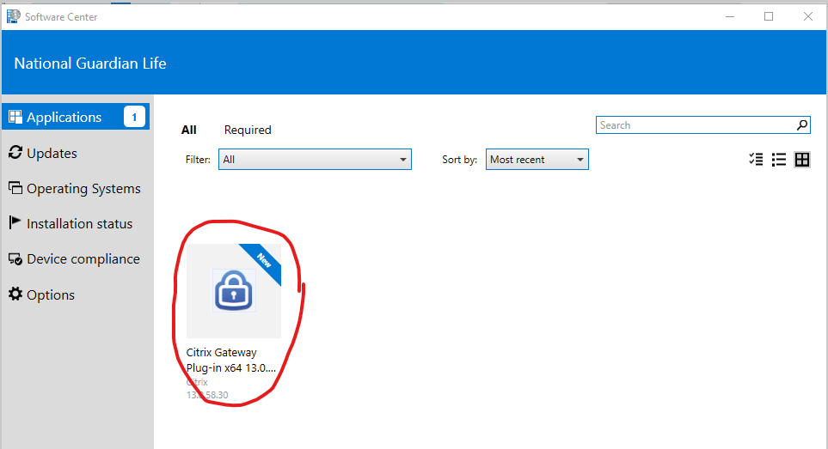
Click on the Citrix Gateway Plug-in x64 13.0.58.30 icon circled above.

- Click the blue Install button circled below:
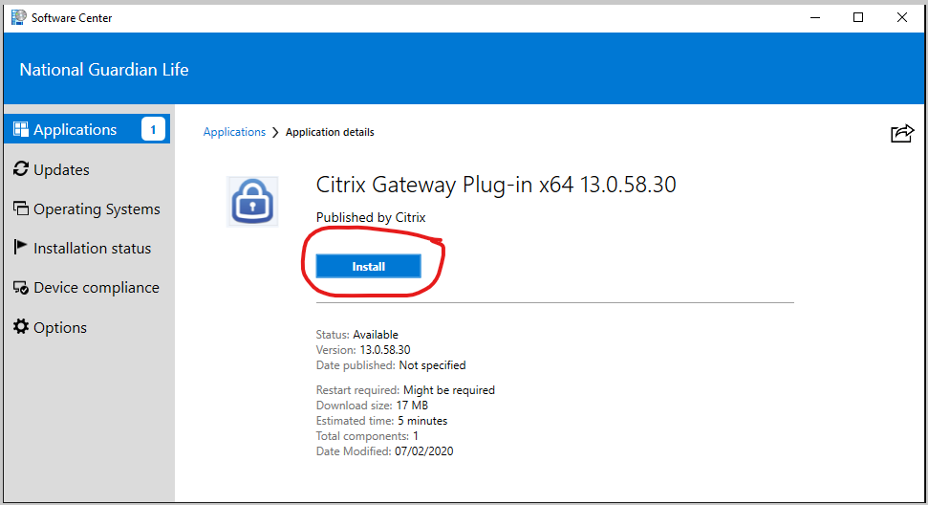

- You will see the status of the download:
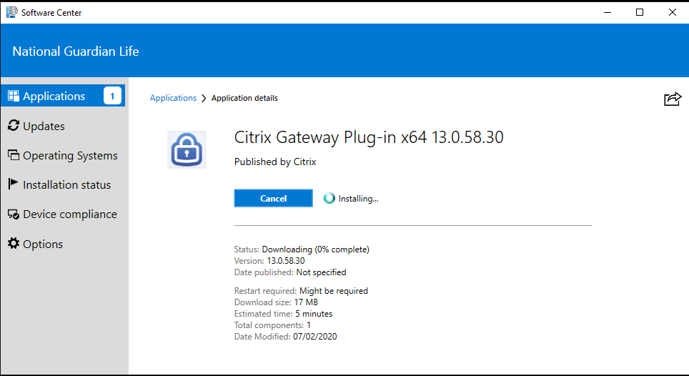

- You will also see the status of the installation:
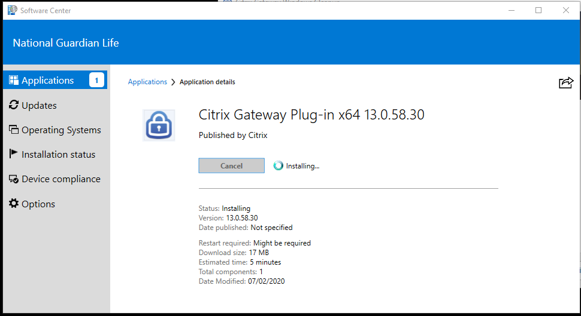

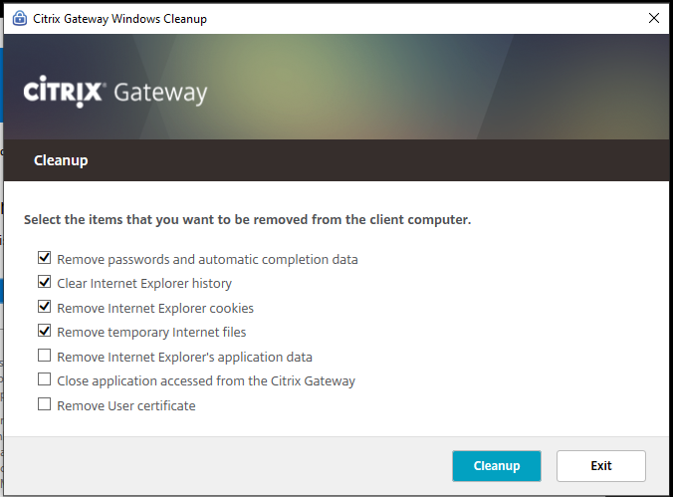
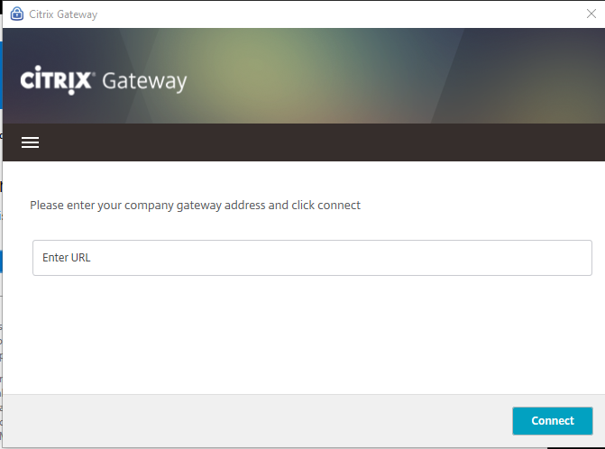
- You may get these pop ups because the VPN connection will be dropped during this process. Just ignore them:

- You may see this pop up below. If so, select Restart now, then click OK.
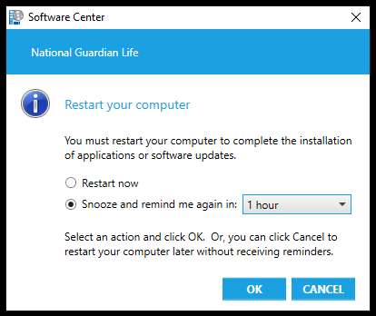

- On this window below, click RESTART.
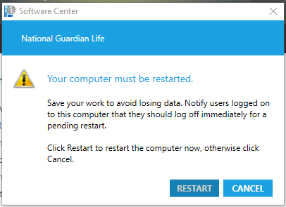

- If you don’t see the box from #10 above, Restart manually:
  - Click ,
  - Then ,
  - Then

- After the reboot, log back into your computer as normal.

- After logging in, you’ll need to reconnect to the VPN.

- Find your NGL VPN icon 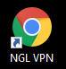, and double-click it.

- On the Citrix Gateway landing page enter your password and click Log On:
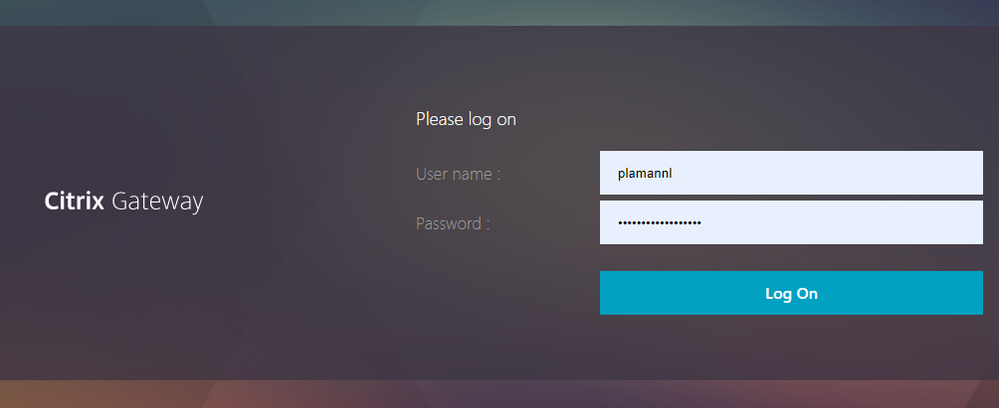

- You’ll see the normal connection screen:
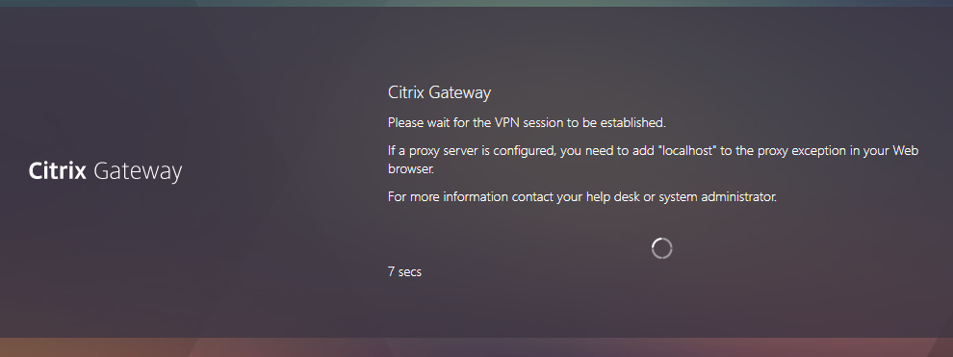

- You may see the Citrix Gateway popup for Starting tunneling … in the bottom right-hand corner:
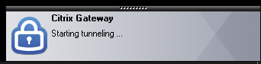

- Once you’re connected, your Skype session should open and the NGL Connections page should open. Go about your normal business day.

Reach out to IT Customer Service at ext. 5555 or 608.257.5611, ext. 5555 if you run into any issues along the way.

