Changing your Password on the VPN
Follow these instructions to reduce your chances of locking your account.
Overview:
- Press CTRL + ALT + DELETE, then click “Change a Password”
- Lock your Computer and unlock with new password (this is the step that is most often forgotten)
- Sign out of your Computer and sign back in with new password

Detailed Instructions:
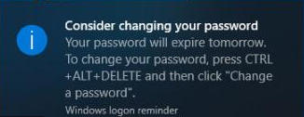
Planning Steps – when you see the notice that your password is about to expire (or every 90 days):
- Start thinking of your new password
- Schedule time to make the change before the last day
Note 1: Weekend days are included in the count down
Note 2: Do not wait until you have 0 days remaining
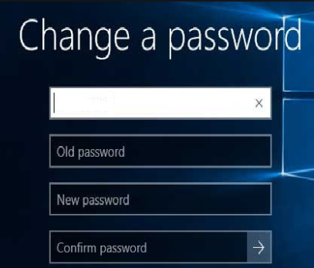
Process for Updating your password on the Network:
- Close all open applications (see Page 2 of this document)
- Hit CTRL + ALT + DELETE on your keyboard
- Select “Change a Password”
- Enter your old password
- Enter your new password twice
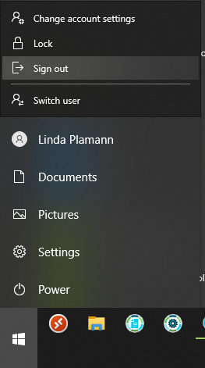
- Click the Arrow or hit Enter to update your password on the network

Process for Updating your password on your Computer:
- Lock your Computer: Hit + L on your keyboard
- Unlock your computer by logging in with your username and new password
- Sign Out:
Click > Click on your name > Click on Sign out (see picture on the right)
- Sign back in with your username and new password

Procedure for Closing Applications
(Whether at home or in the office)
Why should you do this? When you close out of sessions without logging out correctly, the sessions get hung in the system and cause resource issues. This can cause slowness or locking (OnBase) for everyone using the application. If everyone logs out correctly, our applications and systems run smoothly.
When you’re done working for the day or need to close an application:
- Close all open applications appropriately:
  - ID3: hit F12 or F3 until you get to the menu screen, then type 90, then hit Enter. Do not click the X to close until your session is logged off.

  - LifePRO: Hit the Esc key until you get back to the main screen, then select Exit. Click OK to confirm.
    - If you have to close LifePRO through Task Manager or if it drops suddenly, please reach out to Kimberly Ranne to kill your open session.

  - OnBase: Finish any processes and unselect any workflow document you may be in. Then close workflow. Then, click the X to close Onbase, or go to File > Exit.

  - Finesse: Make yourself Not Ready, then click the Logout button to logoff and close the window.

  - SoftPhone:
    - Close the IP Communicator by clicking the X.

  - PTE and other Financial Apps: Please make sure to log out before closing.

  - Citrix Applications (OnBase, Win 10 VDI):
    - OnBase: Close per the above instructions.
    - Win 10 VDI: Close all open applications per the above instructions. Then, Sign Out, Log out, or Disconnect the Citrix Session.

  - All other applications or browser windows: Log out (if applicable), then close out of all other open applications or browser windows.

- Restart your computer. If you have a laptop, wait for the Bitlocker screen to appear, then enter the Bitlocker password.

- Power off monitors. (be sure to remember to power these on in the morning when you log in)
Note: Regarding whether to log out of the VPN, we will have more instructions shortly. Currently, you do not need to click on the VPN Logoff icon on your desktop before Step 2, Restarting your computer.
If you have questions about this process, please reach out to your Manager or Team Lead.
Thank you!

