How to:
Set up and use WebEx

- Get an account – if you don’t have one, have your manager submit a Service Desk Request so access can be added for you and anyone else on your team.
- Once you have an account:
  - Your username will be the same as your network username (what you use to log into your computer).
  - Your password is not your network password. Your one-time password will be emailed to you. Then you will be prompted to update it the first time you log in. This does not change every 90 days.
- Log in on the WebEx portal for the first time to validate your account.
  - Nglic.webex.com
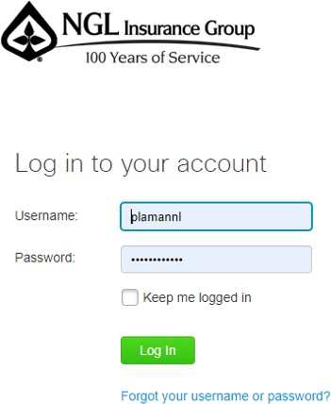

  - Reset your password when prompted.
  - Keep that password safe – it will not change every 90 days.

- Once you’ve reset your password, you have the option of scheduling meetings inside Outlook, on the Cisco WebEx Meetings Desktop App, or on the Web Portal.

To set up the Outlook/WebEx connection:
    - On your Home Ribbon, find the Cisco section.
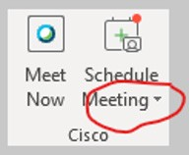
    - Click the drop-down arrow next to Schedule Meeting.
    - Select Preferences.
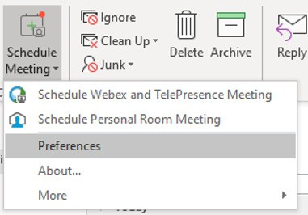
    - In the Preferences window, click Account.
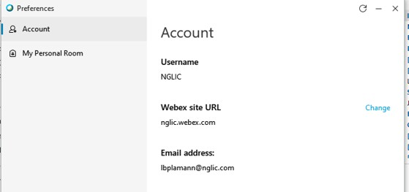
    - Enter in:
      - Your username (network username).
      - WebEx site URL (nglic.webex.com).
      - Email address (your email address).
      - If you have the NGLIC username info in this window, click Change to update the info to your account.

To create a meeting in Outlook:
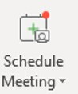
    - Click the schedule Meeting button on the Home Ribbon.

    - Enter your normal meeting info:
      - Title, Required Invitees, Location, Date, Time, Etc.
      - Add your agenda and meeting notes in the body of the message above the text shown.
      - Do not delete or modify anything under the line of text in the body.
    - Click Send
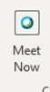
    - Alternatively, click Meet Now to start a meeting in your Personal Room and invite attendees at that time.

To create a meeting in the Desktop App:
    - Click the Windows button.
    - Type Cisco WebEx Meetings.
    - Hit enter.
    - Your credentials should already be entered, but if not, click the gear in the upper right-hand corner and select Preferences.
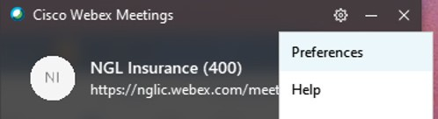

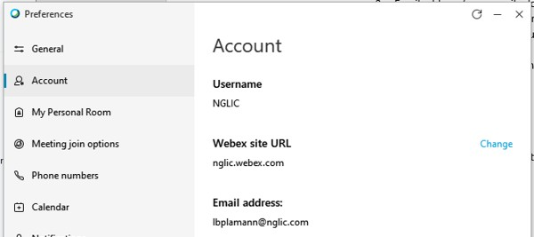
    - Select Account and enter your credentials here.

    - Select Schedule to bring up the Outlook meeting window to enter your meeting information. Or click Start a Meeting to initiate a meeting in your Personal Room. From there, you can invite attendees.

To schedule a meeting using the portal:
    - Login at nglic.webex.com with your WebEx credentials.
    - Click Schedule to set up a future meeting.
    - Click Start a Meeting to initiate a meeting in your Personal Room and invite people at that time.

