- Log into your laptop/desktop.

- Download the receiver at: https://www.citrix.com/downloads/workspace-app/windows/ workspace-app-for-windows-latest.html

- Open Chrome and log into the VPN (nglvpn.nglic.com).

- Open a new tab in Chrome and navigate to https://storefront.nglic.com/Citrix/StoreWeb

- A security warning will pop up. Click “Advance” and then click “Proceed to storefront.”

- On the Welcome to Citrix Receiver page, click Detect Receiver.
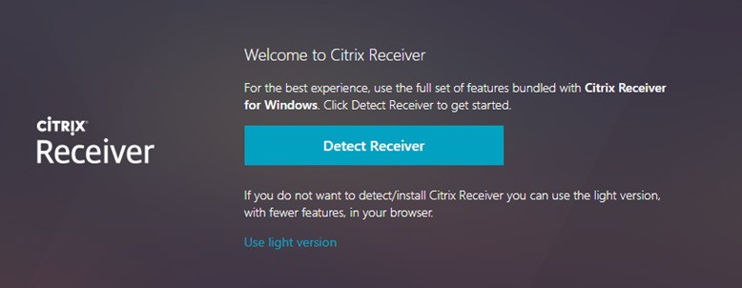
  - If you have the Citrix Receiver installed, it will detect it and take you to the logon screen in Step 5.
  - If you don’t have it installed, it will prompt you to download and install it now. Follow the instructions and click Next until you get to Finish.
  - You may be prompted to restart your computer after the installation completes.

- On the Citrix StoreFront page, log on with your Network credentials.

- This is the landing page you should see when you log in:
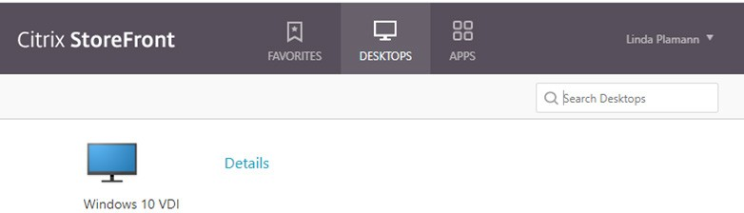

- Click the Apps tab at the top of the page to see the application list.
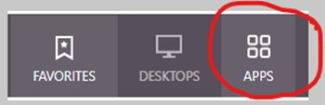

- Find the OnBase Client icon in the list.

- Make sure that about 1 minute has passed after your login on Step 5.

- After 1 minute, click on the Onbase Client icon to launch OnBase.

- Proceed with your work in OnBase as normal.

