NGL Soft VPN Instructions

- Turn on laptop/PC and allow all programs to start up.
- Connect to the internet using a wireless connection/hardwire connection.
- Launch Chrome – only Chrome is supported.
- Type in https://nglvpn.nglic.com/ into the Chrome browser and hit enter.
- A popup will appear at the top of your browser.
Make sure you select the checkbox that says “Always open links of this type in the associated app” – you should only have to do this the first time

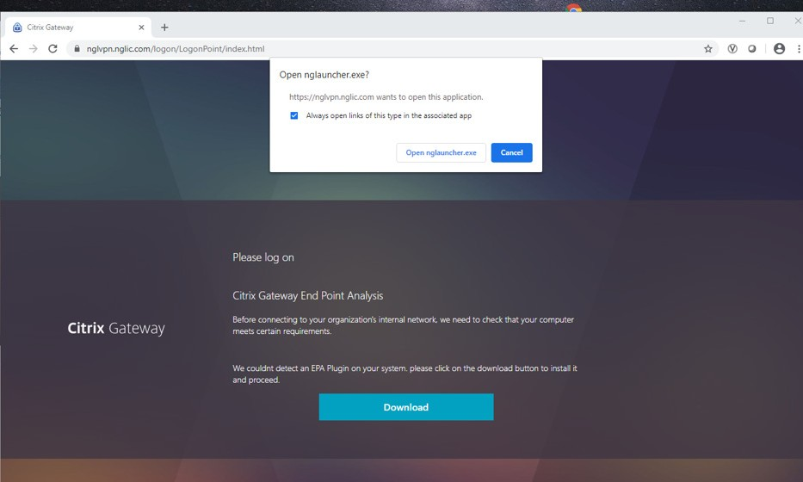6.
you use VPN.
Select “Open nglauncher.exe.”

- 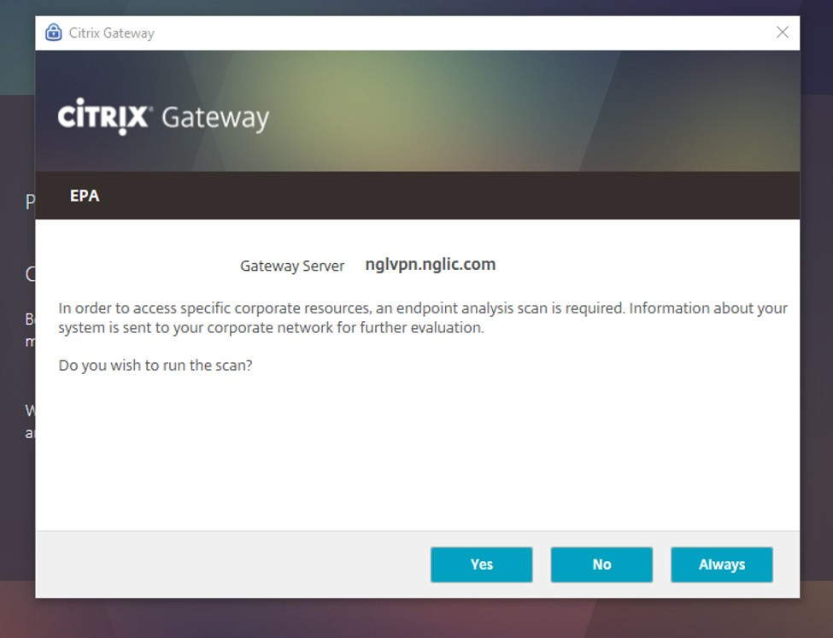On the EPA screen, select “Yes.”

- 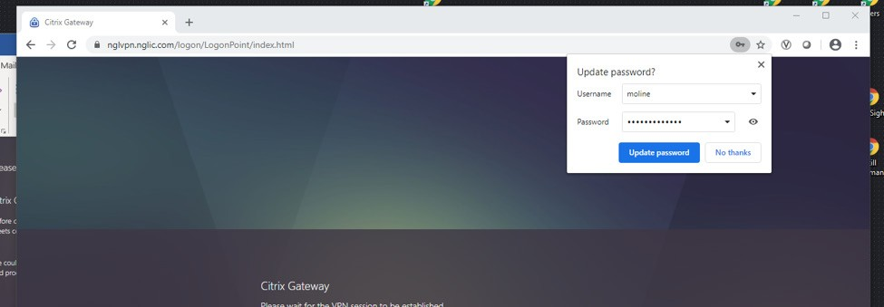Select ‘No thanks” when asked to save password.

- Enter your active directory username/password. This is the same username/ password as you would use when you normally login at work. Select “Log On.”
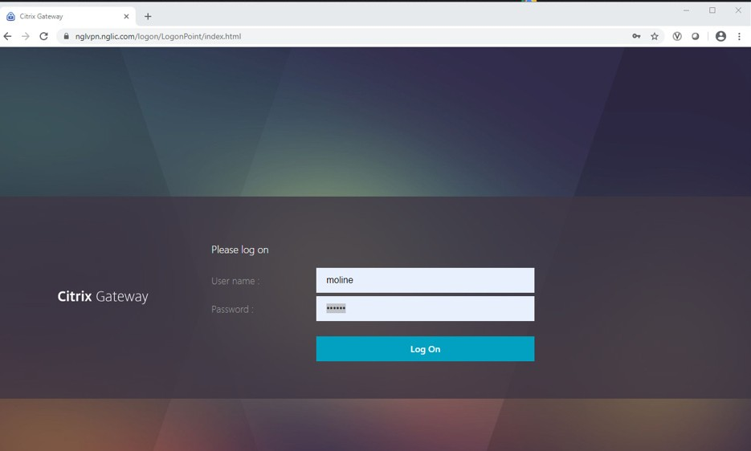

- You will see this Citrix Gateway page once you are logged in.
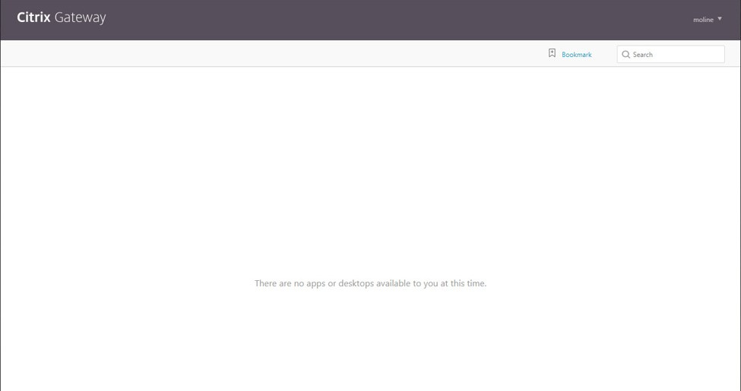

Please leave the Citrix Gateway page open in your browser during your session.

Congratulations! You are now using VPN on the NGL network via your wireless/ hardwire connection. Use your laptop/PC just like you are physically in the office.
This means that you can launch Outlook, ID3, LifePro, etc. like normal workflows.

Options for logging out
Option 1: When you wish to exit the network, log out of your VPN session using
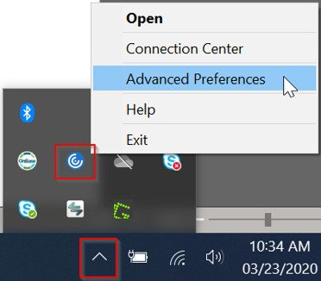
the “Log Off” function at the upper right-hand corner of the browser window.
Option 2: Click the arrow button on the task bar, right click on the Citrix icon and select Advanced Preferences.

In the Advanced Preferences window, click NetScaler Gateway Settings and select
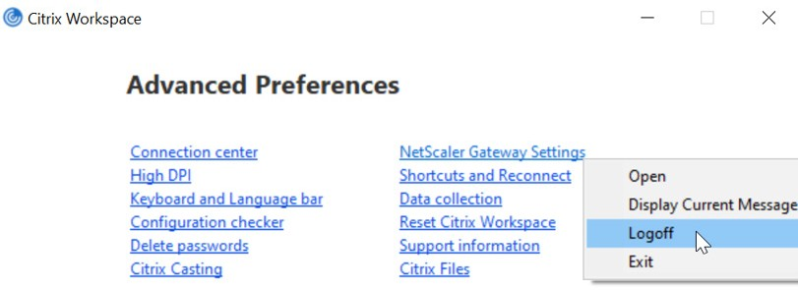
Logoff.

