

**How to:**

**Configure Softphone on PC**

1. Click on Start Menu.

a. Find Cisco IP Communicator in the list.

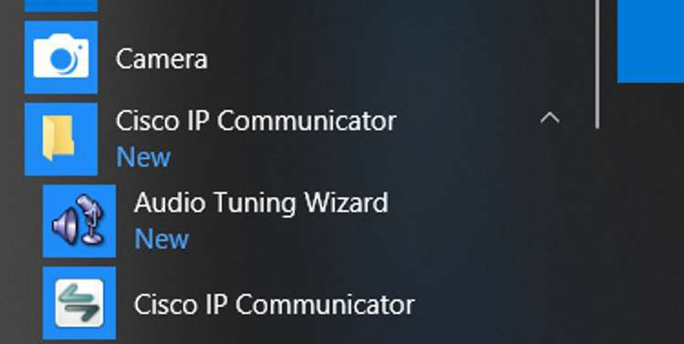

1. Right click the Cisco IP Communicator.

a. Select “Run as administrator.”

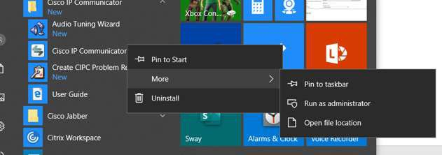

1. Once the Softphone is launched, click on the settings button.

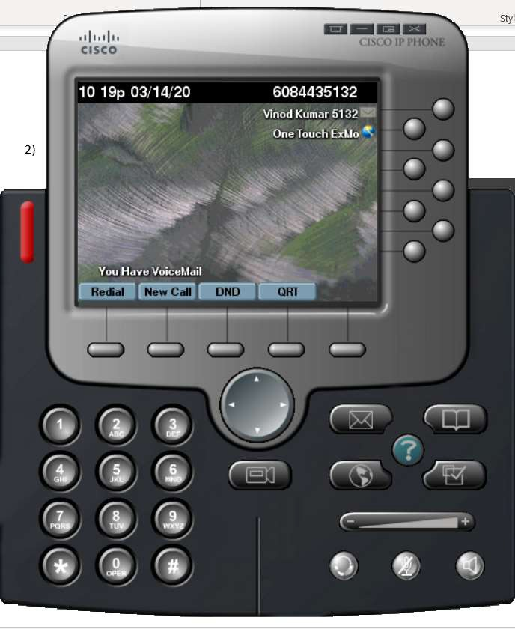

1. Select Preferences.

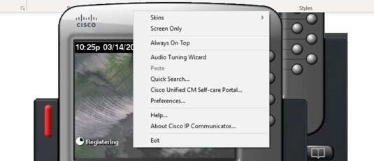

1. Select the Network tab.

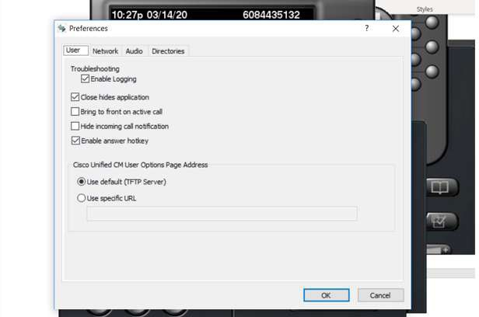

1. In the Network tab, click on “Use this Device Name.” Device Name is a combination of SEP00000000 (eight zeroes) and the last four digits of your personal extension.

Example: Phone with ext. 5132 will be SEP000000005132

1. Check to make sure TFTP address is set to 10.3.51.13 and 10.30.51.10
2. Click OK.

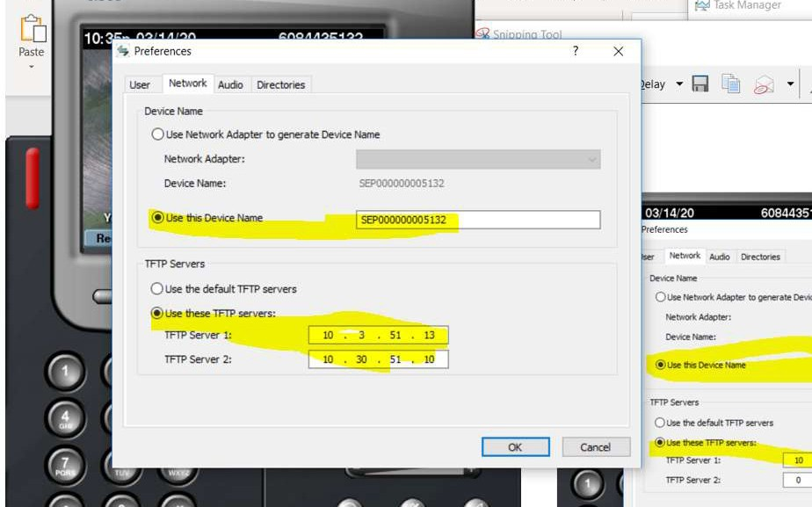

# At this point, your phone will register with NGL phone system.



1. The next step is **required** for you to bring your contact center lines to your Softphone.
   1. Click on the Service OneTouch ExMO (as shown).

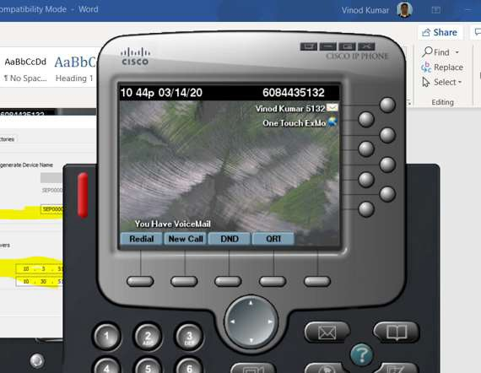

* 1. You will see a similar screen with your ACD and all other lines.

# All your contact center calls will now come through your Softphone.

**If you need assistance, please contact the Service Desk.**